**Project Design Phase-II**

**Data Flow Diagram & User Stories**

|  |  |
| --- | --- |
| Date | 15 October 2022 |
| Team ID | PNT2022TMID27105 |
| Project Name | Smart Farmer - IoT Enabled Smart Farming Application |
| Maximum Marks | 4 Marks |

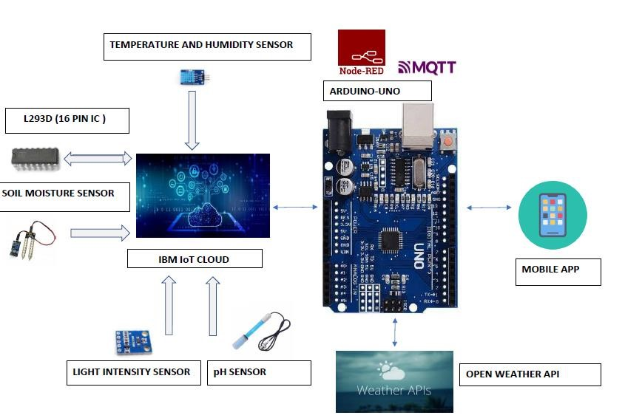

**User Stories**

Use the below template to list all the user stories for the product.

|  |  |  |  |  |  |  |
| --- | --- | --- | --- | --- | --- | --- |
| **User Type** | **Functional**  **Requirement (Epic)** | **User Story**  **Number** | **User Story / Task** | **Acceptance criteria** | **Priority** | **Release** |
| Customer  (Mobile user) | Registration | USN-1 | As a user, I can register for the application by entering my email, password, and confirming my password. | I can access my account / dashboard | High | Sprint-1 |
|  |  | USN-2 | As a user, I will receive confirmation email once I have registered for the application | I can receive confirmation email & click confirm | High | Sprint-1 |
|  |  | USN-3 | As a user, I can register for the application through Facebook | I can register & access the dashboard with Facebook Login | Low | Sprint-2 |
|  |  | USN-4 | As a user, I can register for the application through Gmail | I can register & access the dashboard with Gmail Login | Medium | Sprint-1 |
|  | Login | USN-5 | As a user, I can log into the application by entering email & password | I can access dashboard with email login | High | Sprint-1 |
|  | Dashboard | USN-6 | As a user I can enter into dashboard by using navigation panel | I can access the dashboard by using navigation panel | High | Sprint-1 |
| Customer (Web user) | Registration | USN-1 | As a user, I can register for the web application by entering my email, password, and confirming my password. | I can access my account / dashboard | High | Sprint-1 |
|  |  | USN-2 | As a user, I will receive confirmation email once I have registered for the web application | I can receive confirmation email & click confirm | High | Sprint-1 |
|  | Login | USN-3 | As a user, I can log into the web application by entering email & password | I can access dashboard with email login | High | Sprint-1 |
|  | Dashboard | USN-4 | As a user I can enter into web dashboard by using navigation panel | I can access into dashboard by using navigation panel | High | Sprint-1 |
| Customer Care  Executive | Registration | USN-1 | As a user I can contact the customer care service through phone or mail medium | I can receive confirmation SMS or email | High | Sprint-1 |
|  |  | USN-2 | As a user I want customer care to answer the questions related to product and services | I can get the problem solved within a day | High | Sprint-1 |
|  |  | USN-3 | As a user I want customer care to register my complaints | I can receive a confirmation message stating my complaint is registered | High | Sprint-1 |
|  |  | USN-4 | As a user I want customer care to collect and analyse consumer feedback | I can get the status of my feedback | High | Sprint-1 |
|  |  | USN-5 | As a user I want customer care to troubleshoot technical problems | I can get the problem solved within a day | High | Sprint-1 |
| Administrator |  | USN-1 | As a user I want the administrator to use good working hardware | I can get a guarantee and warranty card | High | Sprint-1 |
|  |  | USN-2 | As a user I want the administrator to sell the product in a reasonable rate | I can get the cost of bill of materials | High | Sprint-1 |
|  |  | USN-3 | As a user I want the administrator to refund my amount if I am not satisfied with the product | I can get an assurance stating I will get my amount back | High | Sprint-1 |